SMART LANDSLIDE DETECTION SYSTEM USING IOT AND MACHINE LEARNING
A PROJECT REPORT
Submittedby

B MALAICHAMY (921722114032 )
K RAJKUMAR (921722114042)
K A VIMAL RAJ (921722114059)

Inpartial fulfillment for the award of the degree
of
BACHELOR OF TECHNOLOGY
IN
ARTIFICIAL INTELLIGENCE AND DATA SCIENCE

SETHU INSTITUTE OF TECHNOLOGY
An Autonomous Institution | Accredited with ‘A’ Grade by NAAC
PULLOOR, KARIAPATTI-626 115.

ANNA UNIVERSITY: CHENNAI 600 025
APRIL 2025

SETHU INSTITUTE OF TECHNOLOGY
An Autonomous Institution | Accredited with ‘A’ Grade by NAAC
PULLOOR, KARIAPATTI-626 115

ANNA UNIVERSITY: CHENNAI 600 025

BONAFIDE CERTIFICATE

Certified that this project report “SMART LANDSLIDE DETECTION SYSTEM USING IOT AND MACHINE LEARNING” is the bonafide work of “MALAICHAMY B (921722114032) , RAJKUMAR K(921722114042) and VIMAL RAJ K A(921722114059) who carried out the project work under my supervision.

SIGNATURE SIGNATURE
DrS.RathnamalaB.Tech.,M.Tech.,Ph.D., Mr. Deepan. T B.E, M.E
Head of the Department Assistant Professor
Department of Artificial Intelligence & Data science Department of AI&DS
Sethu Institute of technology Sethu Institute of technology
Pullor, Kariapatti-626115. Pullor, Kariapatti-626115.

Submitted for the project viva-voce conducted on_____________

INTERNAL EXAMINER EXTERNAL EXAMINER

ACKNOWLEDGEMENT
First, we would like to thank GOD the almighty for giving us the talent and opportunity to complete our project. We wish to express our earned great fullness to our Honorable Founder and Chairman, Mr.S.MOHAMED JALEEL B.Sc., B.L., for his encouragement extended us to undertake this project work.
We wish to thank and express our gratitude to our Chief Executive Officer Mr.S.M.SEENI MOHIDEEN B.Com., M.B.A.,Joint chief executive officer, Mr.S.M.SEENIMOHAMED ALIAR MARAIKKAYAR B.E.,MBA.(UK).,M.E.,(Ph.D).,Director AdministrationMs.S.M.NILOFER FATHIMA B.E.,M.B.A.,(Ph.D) andDirector R&D Dr.S.M.NAZIA FATHIMA, B.Tech.,M.E.,Ph.D., for their support in this project.
We would like to thank and express our gratitude to our respected Principal, Dr.A.SENTHIL KUMAR B.E., M.E.,Ph.D., for providing all necessary for the completion of the project. We wish to thank and express our gratitude to our Vice Principal, Dr.G.D.SIVA KUMAR B.E., M.E.,Ph.D., for his support to our project work.
We wish to express our profound gratitude to our Dean & Professor Dr.S.SIVA RANJANI B.E.,M.E.,Ph.D., and the Head of the Department Dr.S.RathnamalaB.Tech.,M.Tech.,P h.D.,for granting us the necessary permission to proceed with our project and who motivated and encouraged us to do this out rival project for this academic year.
Our profound ,delightful and sincere thanks to our project guide Mr. Deepan . T B.E, M.E whose support was inevitable during the entire period of our work.
We thank our teaching staff for sharing their knowledge and view to enhance our project. We thank our parents for giving us such a wonderful life and our friends for their friendly encouragement through out the project.Finally,we thank the almighty for giving the full health to finish the project successfully.
TABLE OF CONTENTS
CHAPTER NO | TITLE | PAGE NO
 | ABSTRACT
 | LIST OF TABLES
 | LIST OF FIGURES
 | LIST OF SYMBOLS & ABBREVIATIONS
1 | INTRODUCTION
 | 1.1 OVERVIEW
 | 1.2 GENERAL
2 | LITERATURE REVIEW
3 | SYSTEM STUDY
 | 3.1 FEASIBILITY STUDY
 | 3.2 ECONOMIC FEASIBILITY
 | 3.3 TECHNICAL FEASIBILITY
 | 3.4 BEHAVIOURAL FEASIBILITY
4 | PROBLEM DEFINITION
 | 4.1 EXISTING SYSTEM
 | 4.2 PROPOSED SYSTEM
5 | SYSTEM REQUIREMENTS
 | 5.1 HARDWARE REQUIREMENT
 | 5.2 SOFTWARE REQUIREMENT
 | 5.3 DESCRIPTION OF TECHNOLOGYB
6 | SYSTEM DESIGN
 | 6.1. ARCHITECTURE DIAGRAM
 | 6.2 FLOW DIAGRAM
 | 6.3 USE CASE DIAGRAM
 | 6.4 UML DIAGRAM
 | 6.5 ACTIVITY DIAGRAM
7 | SYSTEM IMPLEMENTATION
 | 7.1 MODULES DESCRIPTION
8 | SYSTEM TESTING
 | 8.1 UNIT TESTING
 | 8.2 INTEGRATION TESTING
 | 8.3 WHITE BOX TESTING
 | 8. 4 BLACK BOX TESTING
 | 8.5 ACCEPTANCE TESTING
9 | RESULTS AND DISCUSSION
10 | CONCLUSION AND FUTURE ENHANCEMENT
 | APPENDIX
 | 11.1 SAMPLE CODE
 | 11.2 SCREEN SHOTS
 | REFERENCES
11 | COs& POs MAPPING
 | LIST OF PUBLICATIONS

ABSTRACT
Landslides are one of the most destructive natural disasters, causing severe loss of life, property damage, and environmental degradation, especially in hilly and high-rainfall regions. Traditional landslide monitoring methods are often limited by delayed response, high cost, and lack of real-time data. To address these challenges, this project proposes an IoT and Machine Learning based real-time landslide detection and early warning system. The system uses IoT sensors such as soil moisture sensors and rain sensors connected to an Arduino Uno to continuously collect environmental data from landslide-prone areas. The collected sensor data is transmitted to a backend server, where it is processed and analyzed using machine learning models trained to predict the likelihood of a landslide occurrence. A Flask-based web application is developed to provide real-time monitoring, prediction results, and alert notifications. The system enables early detection of potential landslides, allowing authorities and local communities to take timely preventive actions. This approach improves prediction accuracy, reduces human intervention, and enhances disaster preparedness, making it an effective and scalable solution for landslide risk management.

LIST OF FIGURES
FIGURENO. | TITLE | PAGENO.
6.1 | Architecture Diagram
6.2 | Flow Diagram
6.3 | Use Case Diagram
6.4 | Activity Diagram
11.2.1 | Dashboard to show prediction
11.2.2 | Training Dataset
11.2.3 | Prediction Dataset

LIST OF ABBREVIATIONS
ACRONYMS | ABBREVIATIONS
COA | IoT
RSA | ML
MEMS | DTC
RSA | API

CHAPTER 1
INTRODUCTION
1.1 OVERVIEW
Natural disasters pose a serious threat to human life, infrastructure, and the environment, with landslides being one of the most frequent and destructive hazards, especially in hilly and mountainous regions. Landslides are commonly triggered by heavy rainfall, soil saturation, geological instability, and human activities such as deforestation and unplanned construction. In countries like India, landslides occur frequently during monsoon seasons, causing loss of life, disruption of transportation, and significant economic damage. Therefore, there is a critical need for an efficient system that can monitor environmental conditions and provide early warnings to reduce disaster impact.
Conventional landslide monitoring methods rely on manual inspection, historical data analysis, and periodic surveys. These approaches are often time-consuming, expensive, and incapable of providing real-time alerts, which may result in delayed responses during sudden environmental changes. Recent advancements in Internet of Things (IoT) and Machine Learning (ML) technologies offer an effective solution for real-time landslide monitoring and prediction.
IoT technology enables continuous monitoring of key environmental parameters using sensors installed in landslide-prone areas. Sensors such as soil moisture and rain sensors collect real-time data related to soil condition and rainfall intensity, which are critical indicators of landslide occurrence. These sensors are connected to microcontrollers like Arduino Uno for data acquisition and transmission to a centralized system.
Machine Learning techniques analyze the collected sensor data to identify patterns associated with landslide risks. By training ML models on historical and real-time data, the system can accurately predict the likelihood of landslide occurrence, enabling early warning generation. In this project, an IoT and ML-based real-time landslide detection and early warning system is developed, with predictions and alerts displayed through a Flask-based web application. The proposed system provides a cost-effective, scalable, and reliable solution for improving disaster preparedness and enhancing landslide risk management.

CHAPTER 2
LITERATURESURVEY
- R. Amirthavarshini et al., “Harnessing LoRa for real-time landslide monitoring and early alerts in Kerala’s terrain”, Geoscience Frontiers, 17(2), March 2025.
This paper proposes a real-time IoT-enabled landslide monitoring framework using low-power, long-range (LoRaWAN) communication and multiple environmental sensors (soil moisture, gyroscope, humidity, piezometer). Sensor data are transmitted to a base station where machine learning (ExtraTrees Classifier) analyzes slope stability in real time. The system generates alerts to both communities and geological agencies, offering a cost-effective and scalable approach for landslide risk management in remote terrains.

- Madhushree Sharma & Shakuntala Laskar, “An IoT Based Landslide Monitoring and Early Warning System for Guwahati City”, International Journal on Applied Physics and Engineering, 4(2), 2025.
This study presents an experimental early warning system for landslides in Guwahati using soil moisture sensors integrated with IoT platforms like ThingSpeak. Real-time environmental data are transmitted to the cloud and analyzed to detect rising risk conditions. The system focuses on rainfall-induced landslide prediction and highlights cloud-based visualization and alert mechanisms

- “ AI and IoT-Based Real-Time Landslide Monitoring and Prediction System”, ResearchGate preprint, 2024–2025.
This recent work integrates IoT sensor networks with machine learning models for short-term landslide prediction and monitoring. The system uses real-time environmental data to forecast landslide occurrence one day in advance. The model enhances prediction beyond threshold-based systems by employing AI methodologies on incoming sensor streams

- “AI and IoT-Based Real-Time Landslide Monitoring and Prediction System”, ResearchGate preprint, 2024–2025.
This recent work integrates IoT sensor networks with machine learning models for short-term landslide prediction and monitoring. The system uses real-time environmental data to forecast landslide occurrence one day in advance. The model enhances prediction beyond threshold-based systems by employing AI methodologies on incoming sensor streams

“IoT based landslide detection system and early warning”, AIP Conference Proceedings, July 2025.

This research develops an IoT-based landslide detection system with diverse sensors deployed in landslide-prone areas. Data from soil moisture, rainfall, and other environmental sensors are streamed to analytical platforms for real-time monitoring and early warning. The system emphasizes scalable sensor networks and cloud analytics to improve situational awareness in hazard zones

CHAPTER 3
SYSTEM STUDY
System study involves a detailed analysis of the existing system and the proposed system to understand their working principles, limitations, and improvements. It helps in identifying the need for the new system and defining clear objectives for development.

CHAPTER 4
PROBLEM DEFINITION
4.1 EXISTING SYSTEM
The existing landslide monitoring systems primarily rely on traditional and semi-automated methods such as manual inspection, geological surveys, and historical data analysis. These methods involve periodic field visits by experts to assess slope stability, soil conditions, and rainfall patterns in landslide-prone areas. While these approaches help in identifying high-risk zones, they are not capable of providing continuous or real-time monitoring.
In some existing systems, basic sensor-based monitoring is implemented using rainfall gauges and soil moisture sensors. These systems operate on predefined threshold values, where alerts are generated only when sensor readings exceed fixed limits. Such threshold-based systems lack adaptability and may fail to detect complex relationships between environmental parameters, leading to inaccurate or delayed warnings.
Most existing systems do not integrate Machine Learning techniques for intelligent prediction. They depend heavily on static rules and historical trends, which are not sufficient to handle sudden environmental changes. Additionally, existing systems often lack a centralized monitoring platform, making real-time visualization, data analysis, and alert dissemination difficult.
Due to these limitations, existing landslide monitoring approaches are often inefficient, time-consuming, and unreliable during extreme weather conditions. The absence of real-time prediction and early warning mechanisms reduces their effectiveness in minimizing damage and ensuring public safety.

4.2 PROPOSED SYSTEM
The proposed system is an IoT and Machine Learning based real-time landslide detection and early warning system designed to overcome the limitations of traditional landslide monitoring methods. The system aims to provide continuous monitoring, accurate prediction, and timely alerts to reduce the impact of landslides in vulnerable regions.
In the proposed system, IoT sensors such as soil moisture sensors and rain sensors are deployed in landslide-prone areas to continuously monitor environmental parameters that influence landslide occurrence. These sensors are interfaced with a microcontroller (Arduino Uno) to collect real-time data. The sensor data is transmitted to a centralized backend server for further processing and analysis.
Machine Learning models are trained using historical and real-time sensor data to identify patterns associated with landslide risk. Unlike existing threshold-based systems, the proposed system uses intelligent prediction techniques to estimate the probability of landslide occurrence with higher accuracy. This enables early warning generation before a disaster occurs.
A Flask-based web application is developed to display real-time sensor readings, prediction results, and alert notifications. The web interface allows authorities and users to monitor environmental conditions remotely and take timely preventive measures. The system is scalable, cost-effective, and suitable for real-time deployment, making it an efficient solution for landslide risk management and disaster mitigation.

CHAPTER 5
SYSTEM REQUIREMENTS
5.1 HARDWARE REQUIREMENT
- Arduino Uno
Arduino Uno is used as the main microcontroller to interface with sensors and collect real-time environmental data.
- Soil Moisture Sensor
This sensor is used to measure the moisture content in the soil, which is a key parameter for detecting landslide-prone conditions.
- Rain Sensor
The rain sensor measures rainfall intensity, helping to identify heavy rainfall conditions that may trigger landslides.
- Jumper Wires
Jumper wires are used to establish connections between sensors and the Arduino board.
- USB Cable / Power Supply
Used to power the Arduino Uno and enable data transmission to the system.
- Personal Computer / Laptop
A computer system is required for data processing, machine learning model execution, and web application hosting.

5.2 SOFTWARE REQUIREMENT
- Arduino IDE
Used to write, compile, and upload programs to the Arduino Uno for sensor data acquisition.
- Python Programming Language
Python is used for developing Machine Learning models and backend processing.
- Flask Framework
Flask is used to create the backend web application for real-time data visualization and prediction.
- Machine Learning Libraries
Libraries such as NumPy, Pandas, Scikit-learn are used for data processing, training, and prediction.
- Web Technologies
HTML, CSS, and JavaScript are used to design the frontend interface of the web application.
- Operating System
Windows or Linux operating system is used for development and deployment.
5.3 DESCRIPTION OF TECHNOLOGY

5.3.1 Internet of Things (IoT)
The Internet of Things (IoT) refers to the interconnection of physical devices embedded with sensors, software, and communication technologies to collect and exchange data over the internet. In this project, IoT technology is used to continuously monitor environmental parameters in landslide-prone areas. Sensors such as soil moisture sensors and rain sensors are deployed in the field to collect real-time data related to soil condition and rainfall intensity. These sensors are connected to a microcontroller, which enables data acquisition and transmission to a centralized system. IoT technology allows remote monitoring, real-time data collection, and improved responsiveness, making it suitable for disaster monitoring applications.

5.3.2 Arduino Uno
Arduino Uno is an open-source microcontroller board based on the ATmega328P microcontroller. It is used as the core hardware component to interface sensors and collect real-time data. Arduino Uno reads sensor values and sends the data to the backend system for processing. Its low cost, ease of programming, and compatibility with various sensors make it ideal for IoT-based monitoring systems.

5.3.3 Machine Learning (ML)
Machine Learning is a branch of artificial intelligence that enables systems to learn patterns from data and make predictions without explicit programming. In this project, Machine Learning models are trained using historical and real-time sensor data such as soil moisture and rainfall. Algorithms like Decision Tree and Random Forest are used to analyze the data and predict the probability of landslide occurrence. Machine Learning improves prediction accuracy compared to traditional threshold-based methods and enables early warning generation.

5.3.4 Flask Framework
Flask is a lightweight Python-based web framework used to develop the backend of the proposed system. It acts as an interface between the hardware system and the web application. Flask receives sensor data, processes it using Machine Learning models, and displays prediction results through a web interface. It supports real-time data handling, making it suitable for monitoring and alert systems.

5.3.5 Web Technologies
Web technologies such as HTML, CSS, and JavaScript are used to design the frontend interface of the system. The web application displays real-time sensor readings, prediction status, and alert notifications in a user-friendly manner. This allows authorities and users to remotely monitor landslide-prone areas and take timely preventive actions.

CHAPTER 6
SYSTEM DESIGN

6.1ARCHITECTURE DIAGRAM
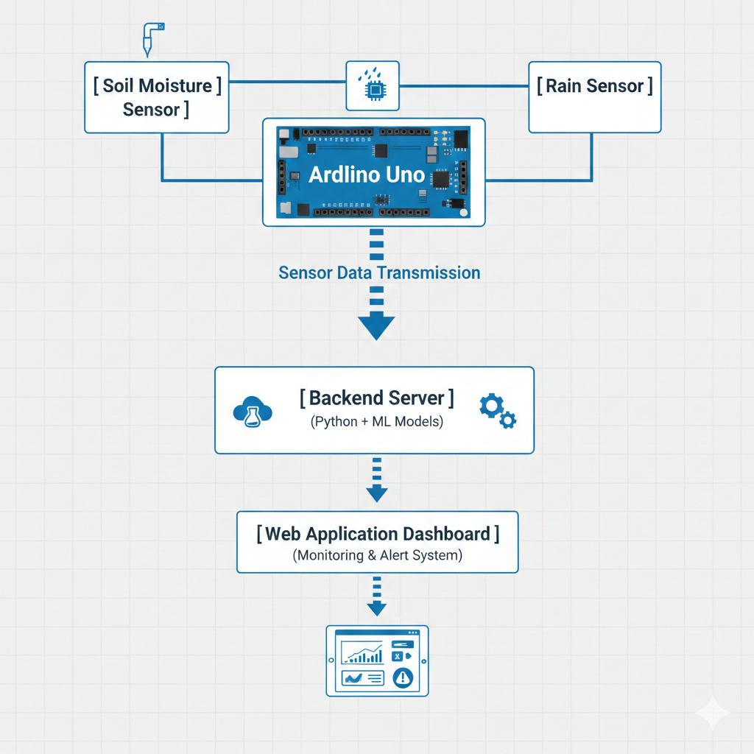

Figure6.1 Architectural Diagram

6.2 FLOW DIAGRAM
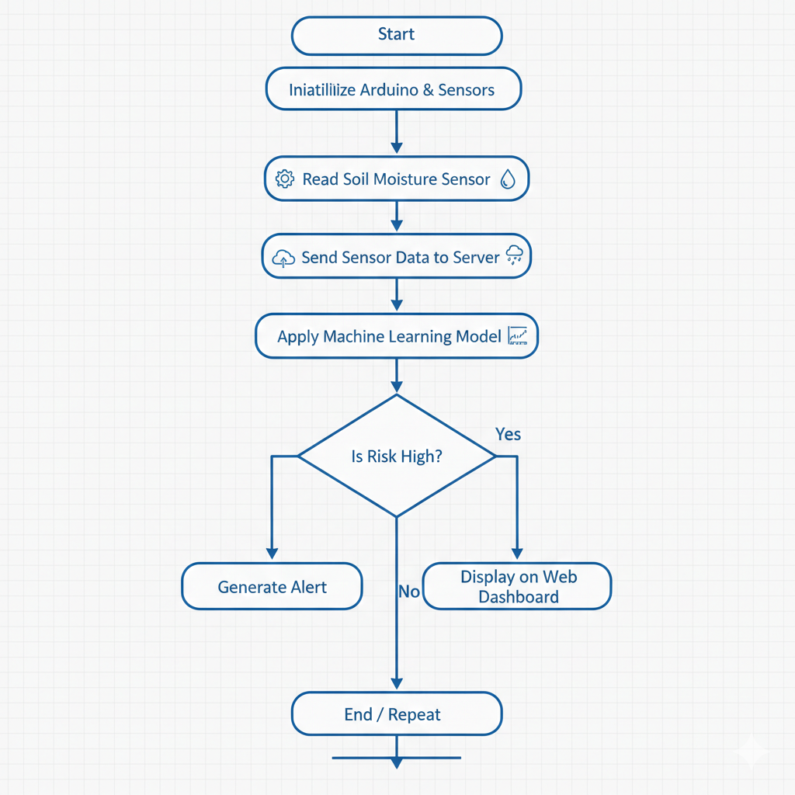

Figure6.2Flow Diagram

6.3 USE CASE DIAGRAM
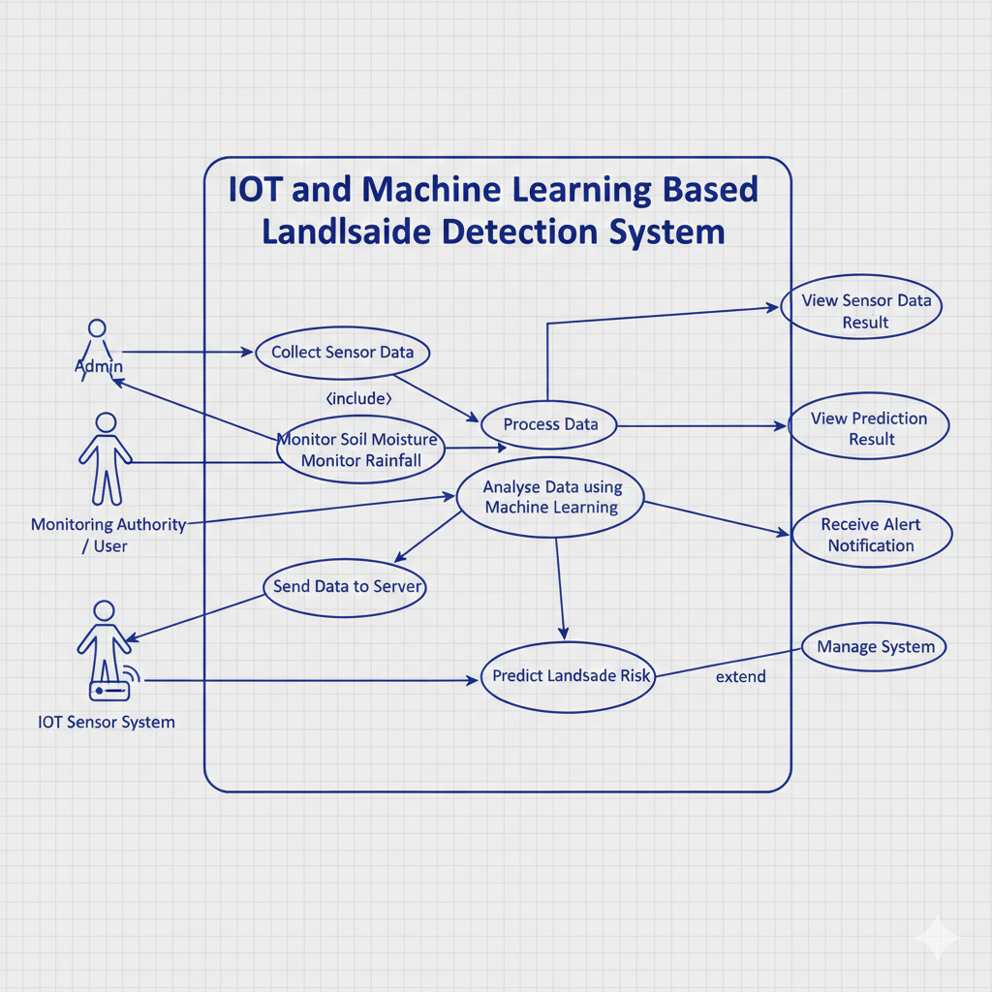

Figure6.3 Use case Diagram

6.4 ACTIVITY DIAGRAM

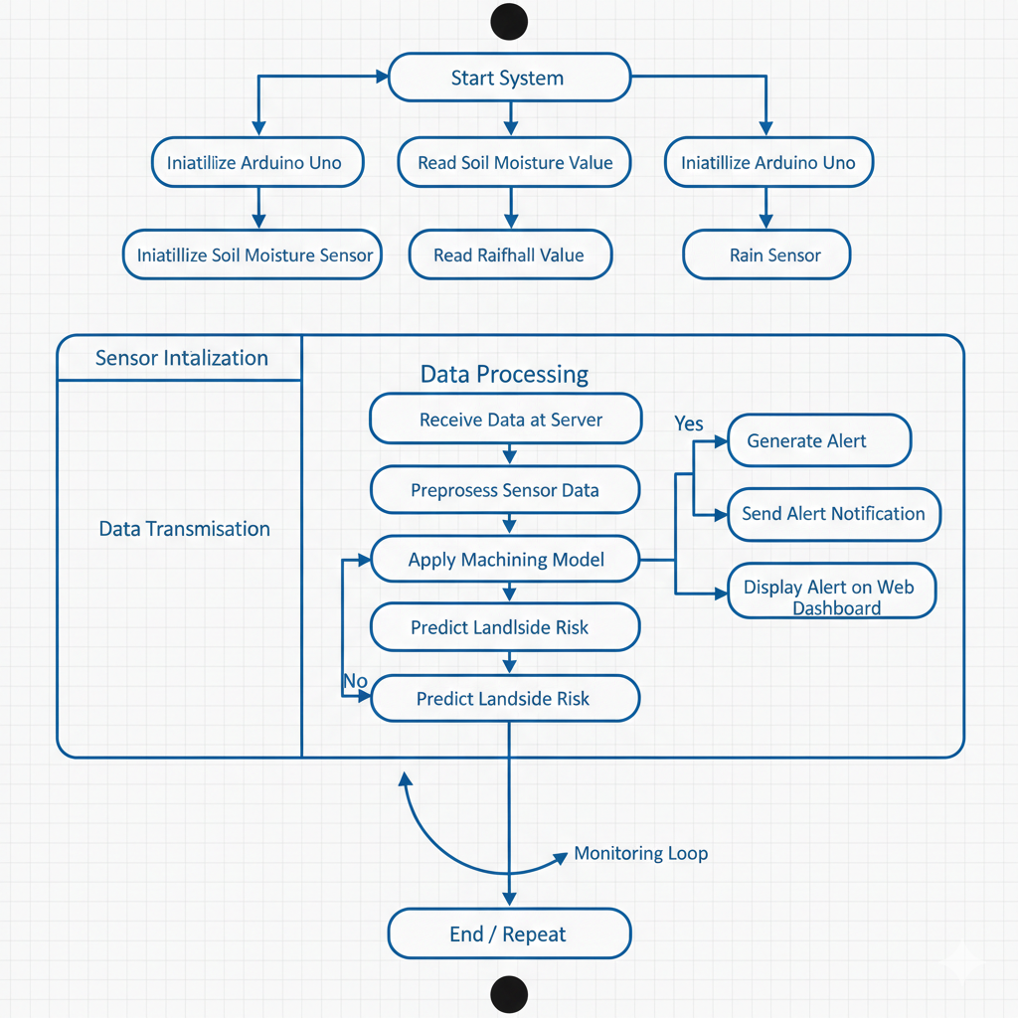

Figure6.4Activity Diagram

CHAPTER 7
SYSTEM IMPLEMENTATION

MODULE SDESCRIPTION

7.1.1 Description
The proposed IoT and Machine Learning based landslide detection system is divided into several modules to ensure smooth data collection, processing, prediction, and alert generation. Each module performs a specific function within the system.

Module 1: Sensor Data Collection Module
This module is responsible for collecting real-time environmental data from landslide-prone areas. Soil moisture sensors and rain sensors are used to monitor soil condition and rainfall intensity. The sensors are interfaced with the Arduino Uno microcontroller, which continuously reads sensor values at predefined intervals.

Module 2: Data Transmission Module
The data transmission module handles the communication between the hardware unit and the backend server. Sensor data collected by the Arduino Uno is transmitted to the server using serial communication. This module ensures reliable and continuous data transfer for real-time monitoring.

Module 3: Data Processing Module
This module preprocesses the received sensor data to remove noise and ensure data consistency. Data normalization and formatting are performed before feeding the data into the Machine Learning model. Proper data processing improves prediction accuracy.

Module 4: Machine Learning Prediction Module
The Machine Learning module analyzes the processed sensor data to predict landslide risk. Trained ML algorithms such as Decision Tree and Random Forest are used to classify conditions as safe or high-risk. This module enables intelligent prediction instead of fixed threshold-based detection.

Module 5: Alert Generation Module
This module generates alerts when the predicted landslide risk exceeds a predefined safety level. Alerts are triggered automatically and sent to the web application for immediate notification. This helps authorities take preventive measures at the right time.

Module 6: Web Monitoring and Visualization Module
The web monitoring module provides a user-friendly interface for real-time visualization of sensor data and prediction results. Developed using Flask, HTML, CSS, and JavaScript, this module allows users and authorities to monitor landslide conditions remotely and receive alert notifications.

CHAPTER 8
SYSTEM TESTING

UNIT TESTING

Unit testing is carried out to verify the correct functioning of individual modules of the proposed landslide detection system. Each module is tested separately to ensure it performs its intended operation before integration with other modules.

The sensor module is tested to check whether the soil moisture and rain sensors correctly read environmental parameters. The data transmission module is tested to ensure reliable transfer of sensor data from the Arduino Uno to the backend server.

The machine learning module is tested by providing sample input data and verifying the accuracy of prediction results. The web application module is tested to confirm proper display of sensor readings, prediction status, and alert notifications.
Unit testing helps in identifying errors at an early stage and ensures the reliability of individual system components.

INTEGRATION TESTING

Integration testing is performed to verify the interaction between different modules of the proposed landslide detection system. After unit testing, individual modules are integrated to ensure smooth data flow and proper coordination among components.

The integration between the sensor module and the backend server is tested to confirm correct data transmission. The interaction between the backend processing module and the machine learning model is verified to ensure accurate prediction. Additionally, the integration of the backend server with the web application is tested to check real-time data display and alert generation.

Integration testing ensures that all modules work together as a unified system without errors.

WHITE BOX TESTING

White box testing is performed to verify the internal logic and code structure of the proposed landslide detection system. In this testing method, the source code is examined to ensure that all possible execution paths, conditions, and loops function correctly.
The backend code is tested by validating data input handling, sensor data processing, and machine learning prediction logic. Conditional statements used for landslide risk evaluation and alert generation are checked to ensure correct execution. The web application logic is also tested to confirm proper data flow and response handling.
White box testing helps in identifying logical errors and ensures that the internal working of the system is accurate and efficient.

BLACK BOX TESTING
Black box testing is performed to validate the functional behavior of the proposed landslide detection system without considering the internal code structure. In this testing method, the system is tested by providing inputs and observing the outputs.
The system is tested using different sensor input values to verify correct prediction and alert generation. The web application is tested to ensure proper display of sensor data, prediction results, and alerts. User interactions such as data viewing and alert notifications are also verified.
Black box testing ensures that the system meets functional requirements and behaves as expected under various input conditions.

ACCEPTANCE TESTING
Acceptance testing is performed to verify whether the proposed landslide detection system meets user requirements and project objectives. This testing is carried out from the user’s perspective to ensure the system is ready for real-world use.
The system is tested to confirm accurate sensor data monitoring, reliable landslide risk prediction, and timely alert generation. The web interface is checked for ease of use, clarity of information, and proper alert notification. Successful completion of acceptance testing confirms that the system satisfies functional and usability requirements.
CHAPTER 9
RESULTS & DISCUSSIONS
The proposed IoT and Machine Learning based landslide detection system was successfully implemented and tested under different conditions. The system continuously monitored environmental parameters such as soil moisture and rainfall using IoT sensors. The collected data was transmitted to the backend server and analyzed using trained machine learning models to predict landslide risk.
The results show that the system accurately detects changes in soil moisture and rainfall intensity in real time. When the sensor values crossed safe limits and matched landslide-prone patterns learned by the machine learning model, the system successfully predicted high-risk conditions. In such cases, alert notifications were generated and displayed on the web dashboard without delay.
The machine learning model provided better prediction accuracy compared to traditional threshold-based methods, as it considered the combined effect of multiple parameters. The web application effectively displayed real-time sensor readings, prediction status, and alerts, making monitoring simple and user-friendly for authorities.
During testing, the system demonstrated reliable performance with minimal delay in data transmission and prediction. However, slight variations in sensor readings were observed due to environmental noise, which can be further improved through advanced filtering techniques and additional sensors.
Overall, the results confirm that the proposed system is effective for real-time landslide monitoring and early warning. The discussion highlights that integrating IoT with Machine Learning significantly improves prediction accuracy, response time, and disaster preparedness compared to existing systems.

CHAPTER 10
CONCLUSION & FUTURE ENHANCEMENT
In this project, an IoT and Machine Learning based real-time landslide detection and early warning system was designed and implemented successfully. The system continuously monitors environmental parameters such as soil moisture and rainfall using IoT sensors and analyzes the collected data using machine learning models. The integration of IoT, Machine Learning, and web technologies enables accurate prediction and timely alert generation. The results demonstrate that the proposed system improves early warning capability, reduces dependency on manual monitoring, and enhances disaster preparedness. Overall, the system provides a reliable and cost-effective solution for landslide risk management.

10.5. Future Enhancements
The proposed system can be further improved by incorporating additional sensors such as tilt sensors, vibration sensors, and ground movement sensors to enhance prediction accuracy. Cloud integration can be implemented to support large-scale data storage and remote access. Advanced machine learning and deep learning models can be used to improve prediction performance under complex environmental conditions. Mobile application integration can be added for instant alert notifications. Additionally, GPS-based location tracking and drone-based monitoring can be introduced for real-time visualization of landslide-prone areas.

CHAPTER 11
APPENDIX
11.1 SAMPLE CODE
from flask import Flask, jsonify, render_template
import serial
import time
import joblib
import numpy as np
import csv
from datetime import datetime
app = Flask(__name__)
# Load trained models and scaler
rf_model = joblib.load("random_forest_model.pkl")
dt_model = joblib.load("decision_tree_model.pkl")
scaler = joblib.load("scaler.pkl")
arduino = None
# Connect to Arduino (change COM port if needed)
print("🔧 Starting Flask backend...")
try:
arduino = serial.Serial('COM12', 9600, timeout=2)
time.sleep(2)
print("✅ Arduino connected on COM12")
except Exception as e:
arduino = None
print("⚠️ Arduino not connected:", e)
soil_value = None
rain_value = None
latest_data = {}

@app.route("/data")
def get_data():
global soil_value, rain_value, latest_data
if arduino is None:
return jsonify({"error": "Arduino not connected"}), 500
if arduino.in_waiting > 0:
line = arduino.readline().decode('utf-8', errors='ignore').strip()
print("🔹 Serial:", line)
if "Soil" in line:
soil_value = int(line.split(":")[1].strip())
elif "Rain" in line:
rain_value = int(line.split(":")[1].strip())
if soil_value is not None and rain_value is not None:
features = np.array([[soil_value, rain_value]])
features_scaled = scaler.transform(features)
rf_pred = rf_model.predict(features_scaled)[0]
dt_pred = dt_model.predict(features_scaled)[0]
# Risk levels
if soil_value < 400 and rain_value < 300:
risk_level = "HIGH"
elif soil_value < 700 and rain_value < 700:
risk_level = "MEDIUM"
else:
risk_level = "LOW"
# 📝 Log predictions to CSV
with open("prediction_log.csv", "a", newline="") as file:
writer = csv.writer(file)
writer.writerow([
datetime.now().strftime("%Y-%m-%d %H:%M:%S"),
soil_value,
rain_value,
rf_pred,
dt_pred,
risk_level
])
latest_data = {
"soil_moisture": soil_value,
"rain_sensor": rain_value,
"rf_prediction": int(rf_pred),
"dt_prediction": int(dt_pred),
"risk_level": risk_level
}
# Reset only AFTER saving
soil_value = None
rain_value = None
# Always return last known data
return jsonify(latest_data)
@app.route("/")
def index():
return render_template("index.html")
if __name__ == "__main__":
app.run(debug=True, use_reloader = False)

11.2 SCREENSHOTS
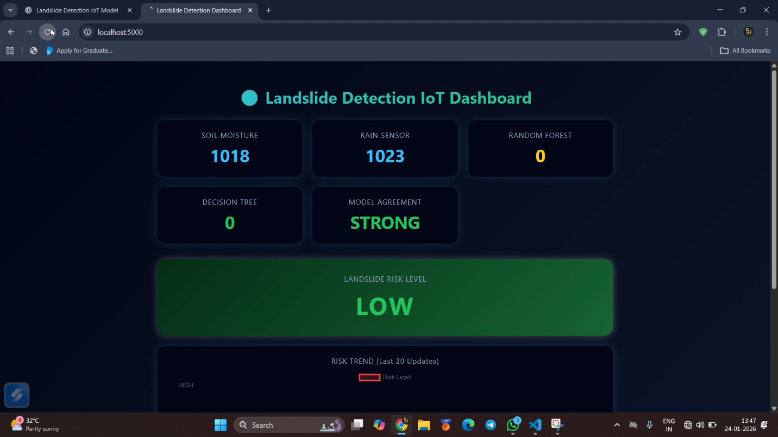
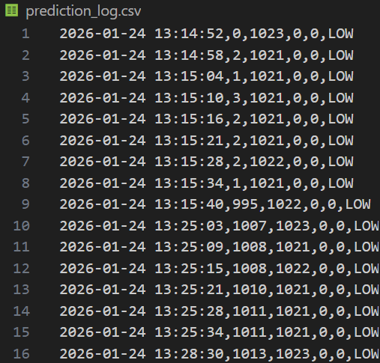
Fig.11.2.1 Dashboard to show prediction
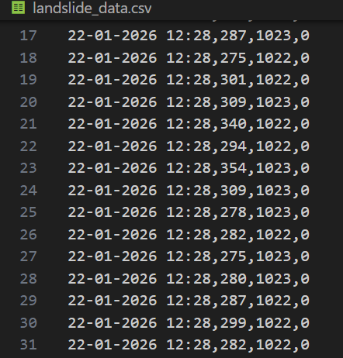
Fig. 11.2.2 Training dataset Fig.11.2.3 Prediction dataset

REFERENCES
[S. K. Saha and R. Sarkar, “IoT-Based Real-Time Landslide Monitoring System,” International Journal of Advanced Computer Science and Applications, vol. 10, no. 6, pp. 312–318, 2019.
R. K. Singh and A. Kumar, “Machine Learning Based Landslide Prediction Using Rainfall and Soil Data,” International Journal of Engineering and Technology, vol. 11, no. 4, pp. 145–152, 2020.
M. K. Prasad and N. R. Babu, “Integrated IoT and Machine Learning Framework for Landslide Early Warning,” Journal of Disaster Risk Reduction, vol. 45, pp. 101–110, 2021.

COs & POs MAPPING
COURSE OUTCOMES
- Design/Develop sustainable solutions for societal issues with environmental considerations applying the basic engineering knowledge.[K6-Create]
- Analyze and review research literature to synthesize research methods including design of experiments to provide valid conclusion. [K4-Analyze]
- Utilize the new tools, algorithms, techniques to provide valid conclusion following the norms of engineering practice.[K3-Apply]
- Test and evaluate the performance of the developed solution using appropriate techniques and tools.[K5-Evaluate]
- Apply management principles to function effectively in the project team for project execution. [A4-Organize]
- Engage in learning for effective project implementation in the broadest context of technological change with consideration for public health, safety, cultural and societal needs. [A3-Value]
- Write effective reports and make clear presentation to the engineering community and society.[A2-Respond]

MAPPING OF COS WITH POS

Course Outcomes | Program Outcomes (POs) |  |  |  |  |  |  |  |  |  |  |  | PSOs
 | 1 | 2 | 3 | 4 | 5 | 6 | 7 | 8 | 9 | 10 | 11 | 12 | 1 | 2
CO 1 | 3 |  | 3 |  |  |  | 3 |  |  |  |  |  | 3 | 3
CO 2 |  | 3 |  | 3 |  |  |  |  |  |  |  |  | 3 | 3
CO 3 |  |  |  |  | 3 |  |  | 3 |  |  |  |  | 3 | 3
CO 4 |  | 3 |  |  | 3 |  |  |  |  |  |  |  | 3 | 3
CO 5 |  |  |  |  |  |  |  |  | 3 |  | 3 |  | 3 | 3
CO 6 |  |  |  |  |  | 3 | 3 |  |  |  |  | 3 | 3 | 3
CO 7 |  |  |  |  |  |  |  |  |  | 3 |  |  | 3 | 3
 | 3 | 3 | 3 | 3 | 3 | 3 | 3 | 3 | 3 | 3 | 3 | 3 | 3 | 3

LIST OF PUBLICATIONS
Hong Zhong, ZhanfeiLi,“Efficient dynamic multi-keyword fuzzysearch over encrypted cloud data”, Journal of Network and ComputerApplications,volume149, pp.102469.

